**PRACTICAL NO. 01**

1. **Write the program for the following:**

**A) Create a program that asks the user to enter their name and their age. Print out**

**message addressed to them that tells them the year that they will turn 100 years**

**old.**

**CODE:**

def fun_to_find_age (name, age):

from datetime import date

current_date = date.today()

year_after = current_date.year + (100 - age)

print("The", year_after," year that you will turn 100 years old. ")

name = str(input("enter name.."))

age = int(input("enter age.."))

fun_to_find_age(name,age)

**OUTPUT:**

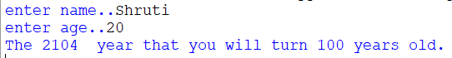

**B) Enter the number from the user and depending on whether the number is even or odd, print out an appropriate message to the user.**

**CODE:**

def evnodd(n):

if n % 2 == 0 :

print("number is even")

else :

print("number is odd")

num = int(input("enter number : "))

evnodd(num)

**OUTPUT:**

 

**C) Write a program to generate the Fibonacci series.**

**CODE:**

def fibo(n):

k = 0

j = 1

print(k)

print(j)

nterm = k + j

while nterm <= n :

print(nterm)

k = j

j = nterm

nterm = k + j

n = n + 1

num = int(input("enter number to fibonacci series : "))

fibo(num)

**OUTPUT:**

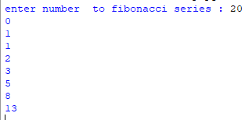

1. **Write a function that reverses the user defined value.**

**CODE:**

def reverse_no(n):

temp = n

rev = 0

while temp > 0:

dig = temp % 10

rev = rev * 10 + dig

temp = temp // 10

print("reverse number is ",rev)

n = int(input("enter number to check it reverse number : "))

reverse_no(n)

**OUTPUT:**





**E) Write a function to check the input value is Armstrong and also write the**

**function for Palindrome.**

**CODE:**

**# To armstrong number**

def armstrong_no(n):

temp = n

length = len(str(n))

sum = 0

while temp > 0 :

dig = temp % 10

sum = sum + dig ** length

temp = temp // 10

if sum == n :

print("number is a armstrong")

else:

print("number is not a armstrong")

n = int(input("enter number to check it armstrong or not : "))

armstrong_no(n)

**# To palindrome number**

def palindrome_no(n):

temp = n

rev = 0

while temp > 0 :

dig = temp % 10

rev = rev * 10 + dig

temp = temp // 10

if rev == n :

print("number is a palindrome")

else:

print("number is not a palindrome")

n = int(input("enter number to check it palindrome or not : "))

palindrome_no(n)

**OUTPUT:**









**F) Write a recursive function to print the factorial for a given number.**

**CODE:**

def fact_cal(n):

if(n == 0 or n == 1):

return 1

else:

return n * fact_cal(n-1)

n = int(input("enter number to find factorial : "))

print("factorial of" , n , " number is ",fact_cal(n))

**OUTPUT:**



